Comet Tail Animation HMI for Speedo and Tacho – s550 Specific - CGEA 1.3

Functional Description
This feature applies to a virtual cluster. The first application is MY18 on the LX cluster on s550, which has a 12.4” TFT display.

As the speedometer and tachometer virtual pointers move, there is an animation that grows as the pointer ascends. This is called the “comet tail”, which gets longer and brighter the faster the pointers move. The comet tail will also turn red on the tach when the tach soft cutout point for the engine is reached.

This function is mostly HMI, with a few places where we want to provide clarification. Thus, this STSS is mapped heavily to explaining the s550 specific HMI which is described in a .ppt presentation that is included as an Appendix in this STSS. The STSS and the presentation and wallpapers/animations from HMI all tie together to describe this feature fully.

Interfaces

Interface Context Diagram (I/O Block Diagram)
Comet Tail Animation HMI Context Diagram

Inputs

IR-REQ-306007/A-INTERNAL
- Operational_Mode
- Display_Units_MC
- Tachometer Gauge Indication (Refer to Tachometer Gauge - CGEA1.3 STSS)
- Speedometer_Gauge (Refer to Speedometer Gauge - CGEA1.3 STSS)

Outputs

IR-REQ-306008/A-INTERNAL
- Speedo_Comet_Tail
- Tacho_Comet_Tail

Function/Performance

F-REQ-306013/A-Operational Modes

Mode | Differentiating Vehicle Conditions
Sleep Mode | Comet Tail Animation Off
Limited Mode | Comet Tail Animation Off
Normal Mode | Comet Tail Animation Functioning
Crank Mode | Comet Tail Animation Functioning

Voltage Levels
Refer to Cluster Features table located in Operational Modes and Voltage Range Strategies Section in this SPSS.

Human-Machine Interface

Visual

Indicator Graphics / Display Format
Example of Comet Tail at maximum brightness
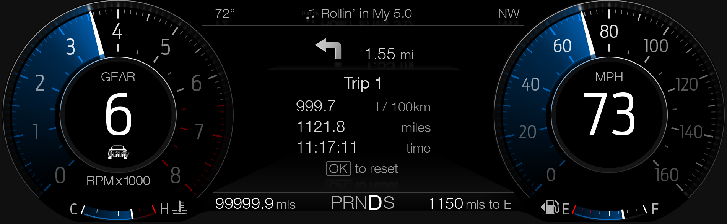

Example of Comet Tail at minimum brightness
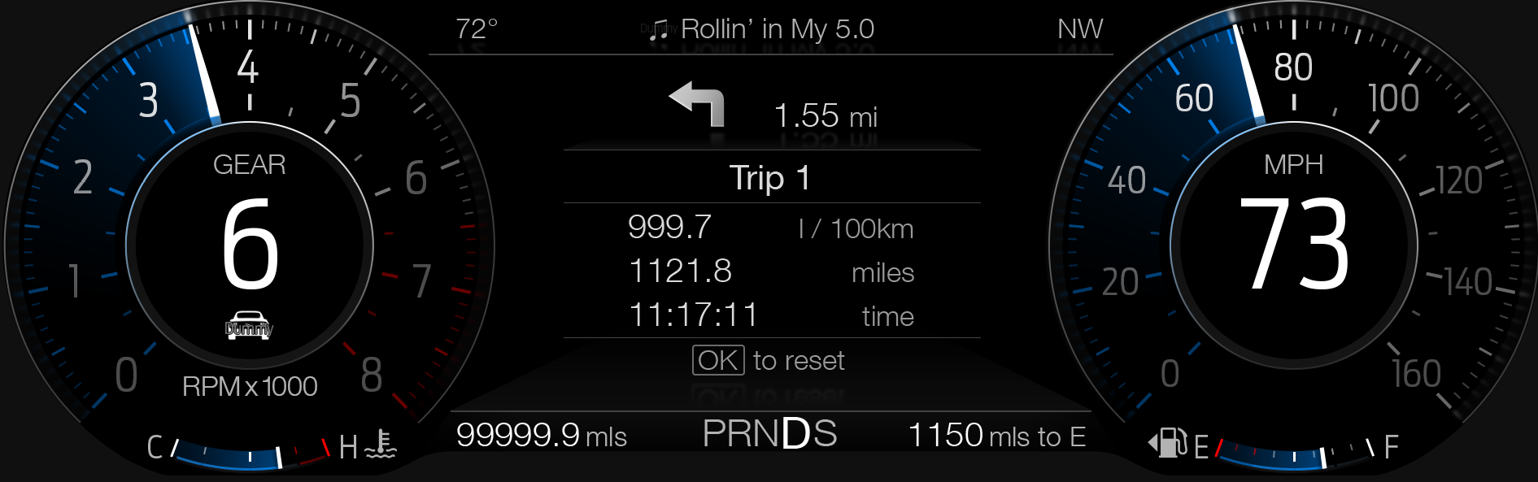

Above are example graphics.
Actual graphics are to be provided by Ford HMI or Studio and approved by the DI Application for each program.

Indicator Color Coordinates
Reference Ford HMI or Studio Wallpaper files for the specific program.

Indicator Characteristics
Reference Ford HMI or Studio Wallpaper files for the specific program.

Audio
None.

Switch Control Logic
None.

PFM-REQ-306012/A-System Accuracy
Within a 100msec of receiving a message that results in a change of state the cluster will update the display to the proper status.

Operation: Performance and Functional

Subsystem Algorithm Flowchart / State Diagram

Maximum Size of Comet Tail

F-REQ-306014/A-Largest Gradient Size
The following defines the largest size of the gradient from its starting point. If the needle moves any further, it will drag the comet tail in its maximum size behind it. It is expected that the supplier shall translate the below tic points into percentage of gauge travel.

F-REQ-305996/A-Normal Mode (both RPM and MPH gauge)
55 increments (chaplets) of 3.4° or 187° total in Normal Mode (both RPM and MPH gauge).

F-REQ-305997/A-Normal + Sport km/h gauge
36 increments (chaplets) of 5.23° or 188° total in Normal + Sport km/h gauge.

F-REQ-305998/A-Sport Mode RPM gauge
55 increments (chaplets) of 4.2° or 20px in Sport Mode RPM gauge.

F-REQ-306000/A-Track Mode RPM gauge
55 increments(chaplets) of 18px in Track Mode RPM gauge
Example:
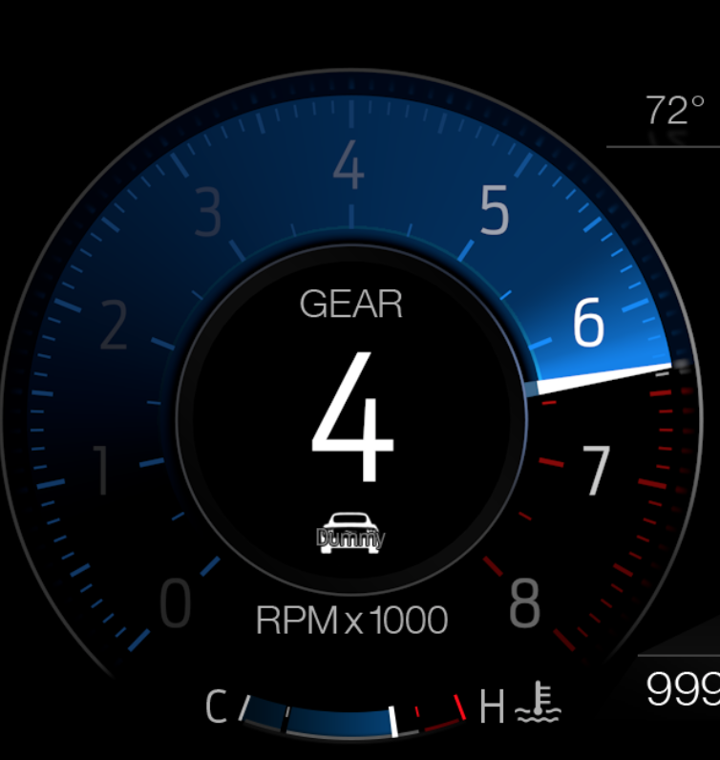

Minimum Size of Comet Tail

F-REQ-306002/A-Smallest Gradient Size
The following defines the smallest possible size of the gradient when the needle is above 800 RPM / 16 MPH / 25 km/h. It is expected that the supplier shall translate the below tic points into percentage of gauge travel.

F-REQ-305974/A-Normal Mode RPM + MPH gauge
8 increments of 3.4° in Normal Mode RPM + MPH gauge.

F-REQ-305975/A-Normal + Sport km/h gauge
5 increments of 5.23° or 26° total in Normal + Sport km/h gauge.

F-REQ-305976/A-Sport Mode RPM gauge
8 increments of 4.2° or 20px in Sport Mode RPM gauge.

F-REQ-305972/A-Track Mode RPM gauge
8 increments of 18px in Track Mode RPM gauge.

F-REQ-305973/A-Comet Tail below 800 RPM / 16 MPH / 25 km/h
Beneath 800 RPM / 16 MPH / 25 km/h, the gradient is compressed completely starting from 0
Example:
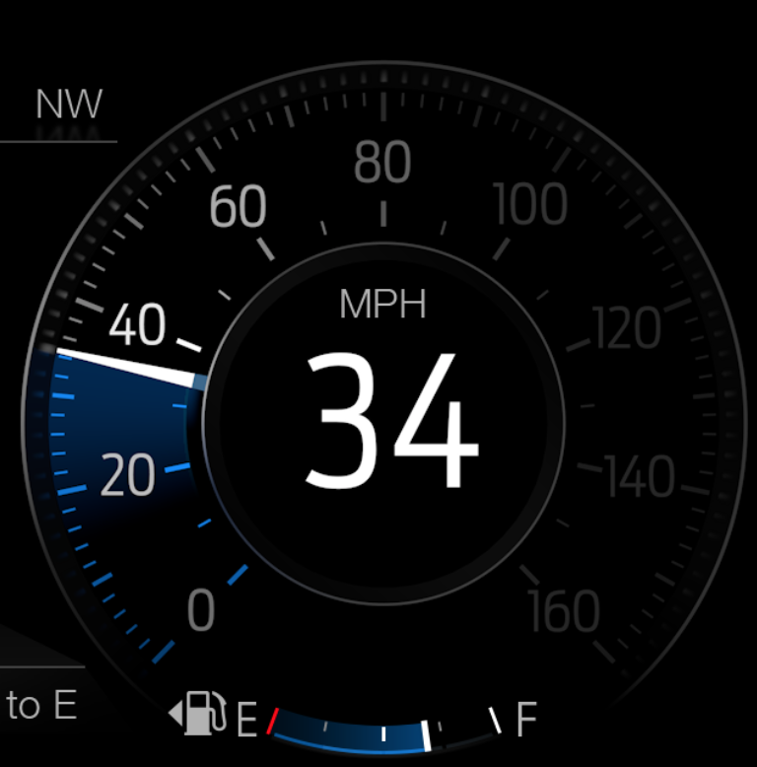

F-REQ-306004/A-Pointer has Minimal or No Motion
Whenever the pointer is not moving or has minimal motion, the comet tail collapses to the minimum size.

Minimal or No Acceleration Definition
Minimal or no acceleration can be specified as follows:

F-REQ-305969/A-Pointer’s Minimal Movement
Pointer is not moving more than 1 increment per second.

F-REQ-305970/A-Comet Tail Collapse Timeout
Comet tail collapses to minimum size after timeout of 1 second. (needle did not move more than 1 increment)

F-REQ-305971/A-Tail Size Increment Trigger Condition
It will stay in this size until the pointer starts accelerating more than 1 increment / s (see HMI animation)

Color of Comet Tail

F-REQ-305999/A-MyColor Settings
The Color is dependent on the MyColor settings.

F-REQ-305977/A-Color and its Display Properties
The exact color, brightness and gradient properties can be extracted from Photoshop deliveries.

F-REQ-305978/A-Tail Color in Fundamental State
The comet tail in its fundamental state is a white to transparent gradient; any color is dynamically applied.

F-REQ-306003/A-Color for Above the Tach Soft Cut Out
For the RPM gauge only: When above the tach soft cutout point for the engine, the color is changed to red, no matter which MyColor setting.

F-REQ-305979/A-Tach Red Color Configuration
The tach color is changed to red when the tachometer gauge indication is in the range defined by the DExx parameter Tach_Redline_Cfg.
Example:
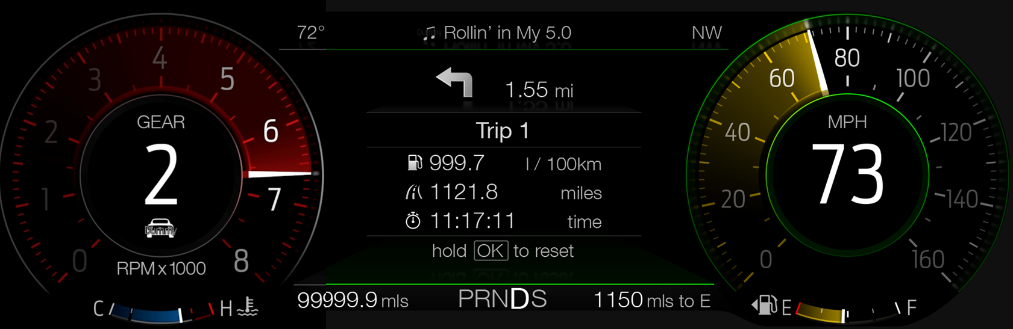

Brightness/Intensity of Comet Tail

F-REQ-306005/A-Pointer’s Acceleration
The brightness or intensity of the comet tail depends on the pointer’s current acceleration (not the car’s acceleration)

F-REQ-305989/A-Brightness with Increasing Needle Speed
There is a dark gradient at 0 rotations per second that gradually becomes brighter with increasing needle speed.

F-REQ-305990/A-Gradient’s Brightest Tone
The gradient reaches its brightest tone at maximum rotation.

F-REQ-305991/A-Maximum Rotation Values and Configuration Table
Maximum rotation is set per WOT (Wide Open Throttle) on an engine type. We shall protect for 2 engine types, corresponding to the Tach_Redline_Cfg as per the table below:

Tach_Redline_Cfg | Rate of Change in RPM for max Tacho brightness  (RPM_ROC) | Rate of Change in km/h for max Speedo brightness
Range 0x1 | 6000 RPM/s (RPM_ROC_1) | 12 mph/s (SPEED_ROC_1)  (note: Corresponds to 0-60 mph in 5.0s)
Range 0x2 or Range 0x3 | 6000 RPM/s (RPM_ROC_2) | 12 mph/s (SPEED_ROC_2)  (note: Corresponds to 0-60 mph in 5.0s)

F-REQ-305992/A-No of Programmable Rates of Change
The 4 Rate of Change parameters in the table above shall be NVM programmable during prototype build phase and shall be accessible to Ford. Preferred implementation is as a Supplier Range writable DID. Exact definition of parameter left to supplier discretion.

F-REQ-305993/A-Darkest Gradient at Zero Rotation
The darkest gradient at zero rotation speed shall vary from R:0 to R:153, G:0 to G:153, and B:0 to B:153.
Example:
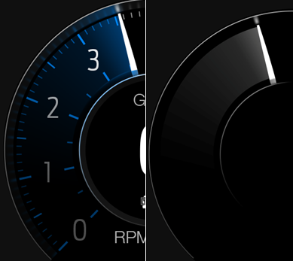

F-REQ-305994/A-Brightest Gradient at Maximum Rotation
The brightest gradient at maximum rotation speed shall vary from R:0 to R:255, G:0 to G:255, and B:0 to B:255.
Example:
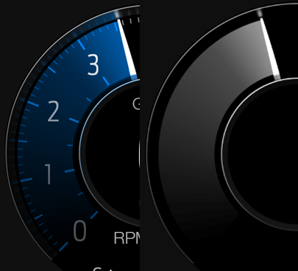

Deceleration of Comet Tail

F-REQ-305995/A-Pointer Movement Counter-Clockwise on Slow Pace
Whenever the pointer is moving counter-clockwise (to left in Sport/Track) on a slow pace, after accelerating slowly, the comet tail collapses to the minimum size with an animation. (For example, while not pushing the gas pedal or slow braking after modest acceleration.)

F-REQ-305980/A-Comet Tail Collapse on Slow Deceleration
While on a slow deceleration, the comet tail collapses to the minimum size with an animation.

F-REQ-305981/A-Slow Deceleration Definition
A slow deceleration is defined as a decel < 3 increments / s.

F-REQ-305982/A-Slow Deceleration Parameter Prototype Phase
During prototype phase, the supplier shall implement the slow deceleration parameter as a Supplier Range writable DID.

F-REQ-305983/A-Tail Size with Needle Backward Movement
While moving “backwards” with the needle, it will always keep the minimum size.

F-REQ-305984/A-Comet Tail Size Change Condition
It will stay in this size until the pointer starts accelerating more than 1 increment / s.

F-REQ-306001/A-Pointer Movement Counter-Clockwise on Fast Pace
Whenever the pointer is moving counter-clockwise (to left in Sport/Track) on a fast pace, the comet tail is replaced immediately with the minimum size comet tail, without any collapsing animation.
(For example, when braking hard after strong acceleration.)

F-REQ-305985/A-Comet Tail Collapse on Fast Deceleration
While on a fast deceleration, the comet tail collapses to the minimum size without animation.

F-REQ-305986/A-Fast Deceleration Definition
A fast deceleration is defined as a decel >= 3 increments / s. (i.e. “Not slow decel”)

F-REQ-305987/A-Tail Size with Needle Backward Movement
While moving “backwards” with the needle, it will always keep the minimum size.

F-REQ-305988/A-Comet Tail Size Change Condition
It will stay in this size until the pointer starts accelerating more than 1 increment / s.

Operation Description (supports algorithm flowchart /state diagram)
None.

FS-REQ-306015/A;1-Function Safety Classification (EMC)
Class B

NVM-REQ-306009/A-Memory Storage

Parameter Name | Description | Value at Battery connect | Value at  Module Wake-up
Display_Units_MC | Input to this routine that controls display indicating units to the driver (i.e. when English: miles, mpg; when Metric: km, L/100 km, km/L). Parameter is to be stored in Battery Backed RAM. | Used Stored Value (See Display Unit Selection Control Function STSS) | Do Not Init
Operational_Mode | Input to this routine that is a 4 State indicator for cluster operational mode | As per Operational Modes and Voltage Range Strategies Section (STSS) | As per Operational Modes and Voltage Range Strategies Section (STSS)

Prove Out
Not applicable.

Reconfigurable Telltale
Not applicable.

Message Center Msg
Refer to text as defined in the Text Translation file.

Error Handling

Missing Message Strategy
None.

Invalid Data Strategy
None.

Diagnostics

Self Test
None.

Engineering Test Mode
Reference section “Dealer / Engineering Test Mode (ETM)”

Part II Performance

Supported Diagnostic Trouble Codes (DTCs)

DTC | Description
None

DID-REQ-306010/A-Supplier Range read/write DIDs during protype builds:

DID | Description
RPM_ROC_1 | Defined in section 1.3.5.1.4 Brightness/Intensity of Comet Tail
RPM_ROC_2 | Defined in section 1.3.5.1.4 Brightness/Intensity of Comet Tail
Speed_ROC_1 | Defined in section 1.3.5.1.4 Brightness/Intensity of Comet Tail
Speed_ROC_2 | Defined in section 1.3.5.1.4 Brightness/Intensity of Comet Tail
Slow Decel Threshold | Defined in section 1.3.5.1.5 Deceleration of Comet Tail

DCR-REQ-306011/A-DID DExx

Bit(s) | State: Description | "0" | “1” | “2” | "3" | Default | Comments/  Information
2 | Tach_RedLine | No Redline | Range 1 | Range 2 | Range 3 | 0x1 (Range 1) | Used by IPCs that have virtual tachometers.  This parameter defined in Tachometer Gauge – CGEA 1.3 STSS.

Reference Specification
IS-0344 GENERAL REQUIREMENTS (MSGCENTR)
IS-0379 NORTH AMERICAN WARNINGS AND INDICATORS STRATEGY

- Appropriate Program Specific Text Translation File
- Appropriate Program Specific IPC Menu Structure File

Revision History
SPSS Module Revision History

Revision Level | Name | Change Description | Date
1.0 | S. Watkins | Initial release with input from Keith Daugherty. | 2/10/2016
1.1 | A. Mishra | Initial VSEM RM Release | 04/11/2018

